Relocating to Romania!

Description of the data and way of working:

1. I will use <https://ro.wikipedia.org/wiki/Lista_ora%C8%99elor_din_Rom%C3%A2nia> to get a list of cities in Romania.

Below is a snip of how the raw data looks like, will only keep the Oraș and Populație (2020) fields sincethe others are not relevant to our study

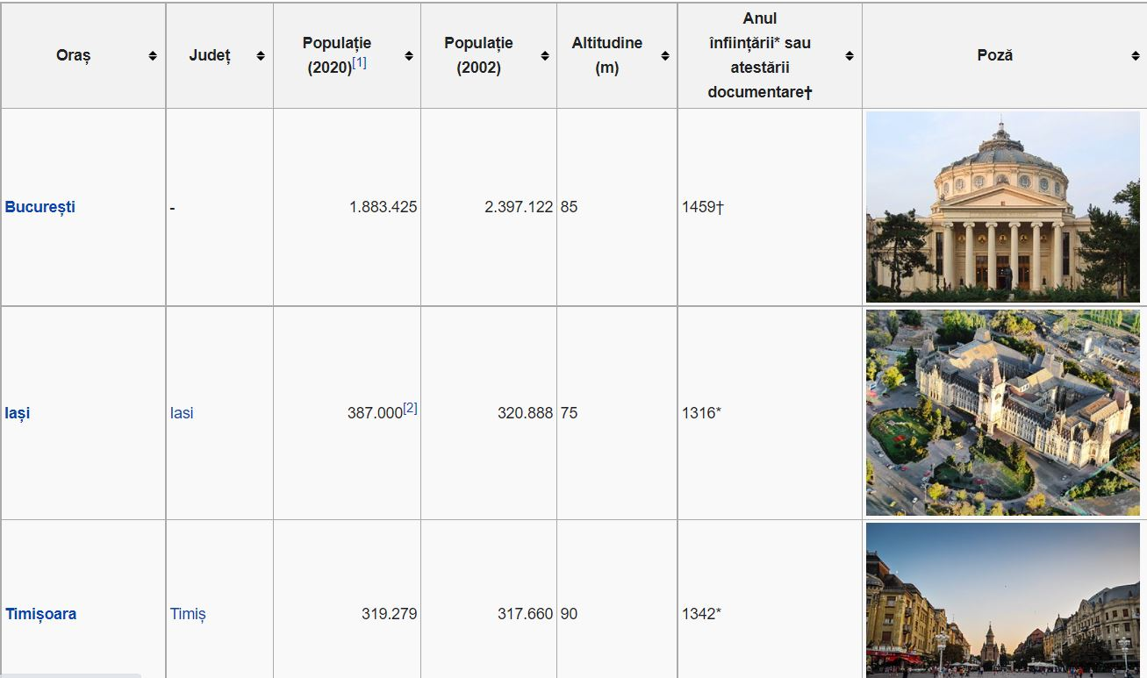

1. The list will be cleaned according to our specifications regarding population
2. After I have the city list I will use **Forsquare to make calls and recive the top 3 fun and food veneus** in each of the city that has met criteria in point 1.

Below is a sample of a web version call from <https://foursquare.com/>

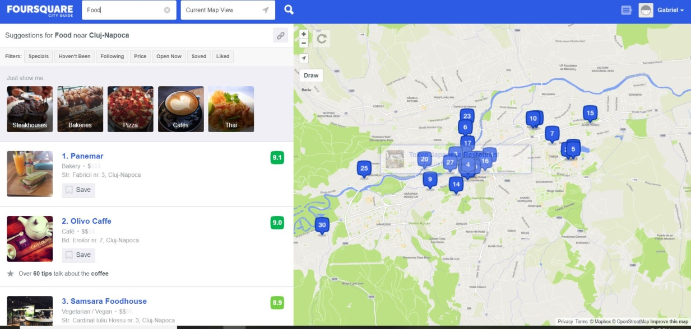

- in the sample we see food sugestions from Cluj-Napoca

1. I will then analise the cities based on the average score of the averege of the two citeria (fun and food)

The database should look similar to the table below:

|  |  |  |  |  |  |  |  |  |  |  |
| --- | --- | --- | --- | --- | --- | --- | --- | --- | --- | --- |
| **City** | **population** | **Food venue 1** | **Food venue 2** | **Food venue 3** | **Average food venue rating** | **Fun venue1** | **Fun venue 2** | **Fun venue 3** | **Average fun venue rating** | **Total average rating** |
| a |  |  |  |  |  |  |  |  |  |  |
| b |  |  |  |  |  |  |  |  |  |  |
| … |  |  |  |  |  |  |  |  |  |  |
| x |  |  |  |  |  |  |  |  |  |  |

After I have all the data I will try to segment them, similar to New York segmenting Lab, only thing is instead of neighborhoods I will have cities.